Data-driven business site research

Capstone project report

Contents

1 Introduction 1

1.1 The concept 1

1.2 Business case 2

1.3 Project question and goals 2

2 Data used 2

2.1 Data on Toronto neighbourhoods 3

2.2 Data acquisition and cleaning 3

2.3 Use of Foursquare API 4

2.4 Use of Yelp API 5

3 Model and clustering outcomes 6

3.1 Clustering of Milan’s neighbourhoods, based on venue composition 6

3.2 Clustering of Milan’s neighbourhoods, based on price tier and rating of food venues 7

4 Outcomes of the data analysis: scenario applications 10

4.1 Scenario 1 – Where to open a given kind of restaurant 10

4.1.1 Introduction 10

4.1.2 Solving the problem 11

4.2 Scenario 2 – Identifying new areas for a luxury shop 12

4.2.1 Introduction 12

4.2.2 Solving the problem 12

5 Extra 15

5.1 Comparison between Milan and Toronto neighbourhoods based on venue composition 15

# Introduction

## The concept

I will be acquiring information regarding Milan's boroughs and will perform an analysis similar to what we have done with Toronto and NY. I am then going to expand the analysis to include other information sources, to get further insight on the city structure. The analysis will provide information on how to distinguish between parts of a city, and how different kinds of neighbourhood (residential, touristic, financial...) might compare.

Comparative analysis between neighbourhoods of different cities is mentioned and reported in an example at the end of the report.

For my analysis, I am going to use information about the most popular venues per neighbourhood, and use it to cluster them. Each neighbourhood popular venues blend, made of restoration, services and attraction venues in different proportions, can in fact give us insights about its geographical location and position relatively to tourism, business or services centres.

I am then going to carry out an analysis of Milan’s neighbourhood based on food venues rating and price tier. The idea is to correlate those two indicators with the neighbourhood location and nearby presence of tourism, business or services centres, possibly comparing it to the previous analysis.

This project is obviously limited in scope but it provides an interesting starting point for further work on the same data and topics.

## Business case

Classification of neighbourhoods provides useful information that can be used to plan investing in a new or existing business, based on the description of the neighbourhood provided.

Classification based on venue composition may provide information about the kind of neighbourhood, e.g. being residential, touristic, business oriented, etc. Understanding similarities between neighbourhoods might unlock opportunities for business development. As an example, think of a business (of any kind) traditionally targeting areas characterised by sports venues, such as a stadium; by carrying out classification of neighbourhoods we might find similarities with other kinds of area, not characterised by sport venues, that would normally be overlooked by the business management. This may unlock opportunities for investment and expansion.

Classification based on venues’ price tier and rating provides useful information not only about the food outlet sector, but also the neighbourhood composition. High prices and ratings may signal trendy and high-end areas, whereas lower prices and ratings might be connected to fast-food outlets, blue collar working areas, shopping areas ,etc. For someone looking into investing in a new or existing business, of any kind, it would be important to identify potential opportunities and gaps in local offerings, and to understand where to find the right clientele for their products.

## Project question and goals

The question I would like to answer with this project is:

*is there a simple way to identify some basic properties of a neighbourhood by using information somewhat related to the people living and working there? Can that information be used for business purposes?*

The goal is to build a simple model that clusters neighbourhoods in a few, well-identifiable groups, characterised by geographical position, proximity or presence of infrastructure or services.

# Data used

Milan data are not readily available as for NY or Toronto; basic information about Milan’s boroughs and neighbourhoods are found on Wikipedia (<https://en.wikipedia.org/wiki/Zones_of_Milan>), and the spatial coordinates can be obtained through services as geocoder.

An alternative and more efficient solution is to use an institutional database, which is available online (<http://dati.comune.milano.it/dataset/5c6519f6-6d26-41c9-b53b-6106e08d1b90/resource/533b4e63-3d78-4bb5-aeb4-6c5f648f7f21/download/ds634_civici_coordinategeografiche_20190902_csv.zip>), and contains spatial coordinates of each and every single address in Milan and relative neighbourhood information. By averaging the coordinates for all addresses specific to one neighbourhood it is possible to get a good estimate of each neighbourhood centre location, especially given the size of the database. Location of the coordinates on the map confirms the correctness of the operation.

Information on the neighbourhood popular venues is then obtained through Foursquare API, whereas data on food venues ratings and price tier is available through Yelp API.

Data from Toronto from the previous part of the project course.

## Data on Toronto neighbourhoods

Data on Toronto has been acquired as part of the project course, in the previous module. Information about neighbourhoods and boroughs was scraped from the Wikipedia page <https://en.wikipedia.org/wiki/List_of_postal_codes_of_Canada:_M> , and the coordinates through the geocoder package, or provided with the course material, depending on the correct functioning of geocoder. I have then acquired information about popular venues in central Toronto through the Foursquare API, and clustered the neighbourhoods according to their venues composition. The result is available on <https://github.com/RaffaToSpace/Coursera_Capstone/blob/master/Toronto_clustering_analysis.ipynb> , and shows how neighbourhoods in central Toronto are pretty homogeneous in composition, with some exceptions due to the presence of services or infrastructure (such as schools, parks, etc.) in some neighbourhoods.

## Data acquisition and cleaning

Once obtained the geographical data of Milan from the institutional website I copied it into a dataframe and proceeded into extracting relevant information from it. The table contains a number of empty cells and non-valid values, requiring cleaning and sorting. I extracted a list of neighbourhoods and averaged the spatial coordinates of all the addresses for each one of them to find the central neighbourhood set of coordinates. Given that each neighbourhood contains at least a few hundreds of addresses, dropping a small fraction of it due to missing details should not affect the final value of the averaged coordinates in a relevant way.

As displayed on a map in Figure 1, the list of neighbourhoods is sufficiently representative of the areas of town and the dots are evenly spaced, except for some representing more isolated areas on the outskirts.

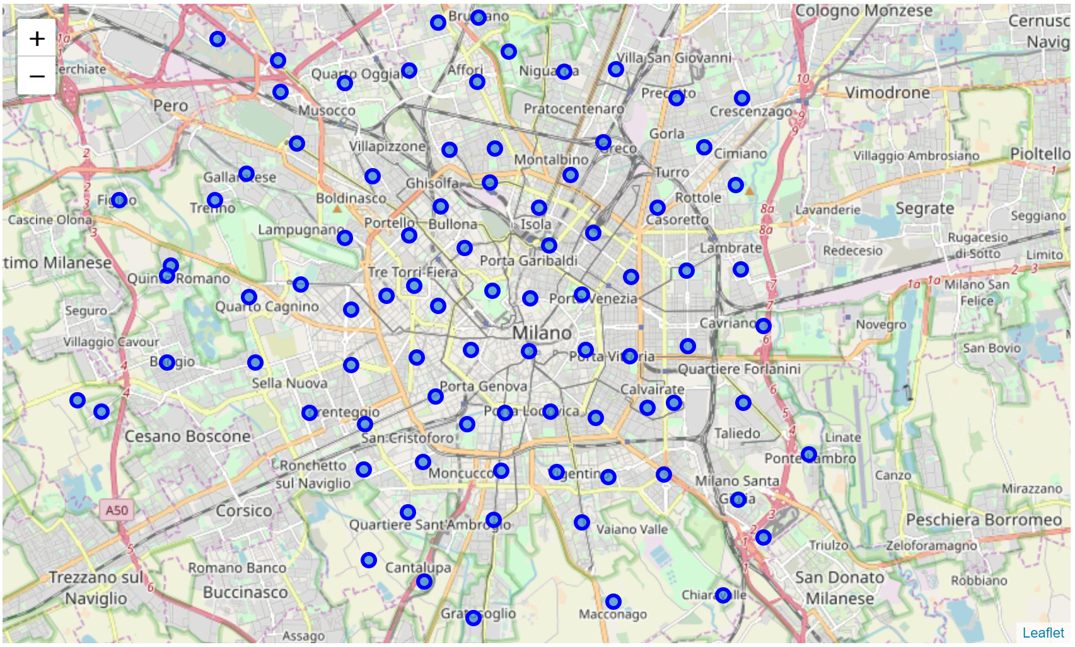

Figure 1 Map of Milan, with location of the neighbourhoods used for the analysis.

## Use of Foursquare API

I used the Foursquare API to acquire information on the venue composition of each area, similarly to what done in the previous parts of the Capstone course. A dataframe of 2370 venues was thus created (Figure 2).

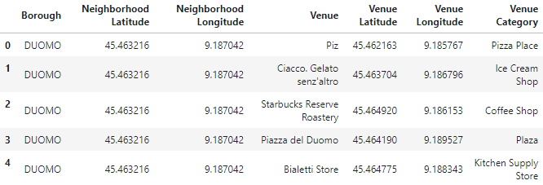

Figure 2 First few lines of the popular venues dataframes obtained through Foursquare API.

I then transformed the dataframe in a “one-hot encoding” format, i.e. in which all the venue categories are extracted and set as dataframe columns, and the value in them represents the relative frequency (values 0-1) of that venue category among popular venues in the neighbourhood. As an example, if “Coffee shop” has value 0.1 for a given neighbourhood, it means that 10% of the popular venues in it are coffee shops. The analysis showed how there are 265 venue categories in the dataframe. This “one-hot encoded” dataframe will then be used for the clustering analysis.

Lastly, I made a dataframe listing the top 10 venue categories per neighbourhood, as shown in Figure 3. This will be used to interpret the results of clustering, and is very easily readable.

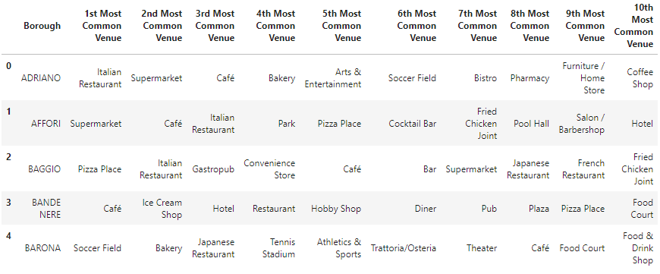

Figure 3 First few lines of the dataframe listing the most popular venues per area.

## Use of Yelp API

Using Yelp API is just as simple as simple as Foursquare’s. Complete instructions on its use can be found on <https://www.yelp.com/developers/documentation/v3/business_search> and <https://python.gotrained.com/yelp-fusion-api-tutorial/>. I used to obtain information about the most popular food venues around each coordinates point representing a neighbourhood, in terms of venue name, price tier and rating. With respect to Foursquare, Yelp is more customer-rating oriented and is thus more reliable for ratings-based analysis. Moreover, Yelp API has a more generous daily allowance of free calls per user, meaning that is easier to collect the required data, and the *json* text file is in my opinion easier to search for information.

The structure of the dataframe generated with information from Yelp is shown in Figure 4.

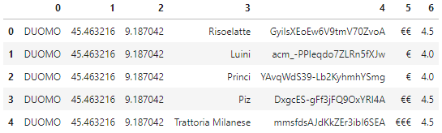

Figure 4 First few lines of the dataframe showing popular food venues per area, their price tier (column 4) and rating (column 5), both on a 1 to 5 scale.

After encoding the price tier information in *float* type numbers, I proceeded into grouping the information by borough, thus getting an average price tier and rating score per borough, plus a combined indicator named *heat*, as shown in the table in Figure 5. The *heat* parameter is in this case the simple sum of rating and price tier, but it can easily be tuned depending on the analysis needs.

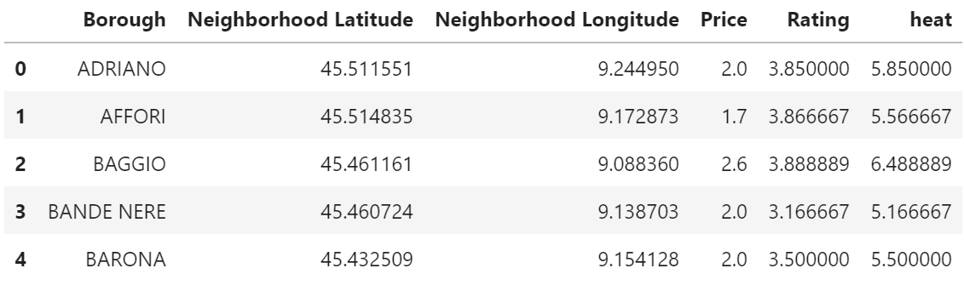

Figure 5 First few lines of the dataframe with average price tier and ratings per area, plus a combined indicator names “heat”.

# Model and clustering outcomes

## Clustering of Milan’s neighbourhoods, based on venue composition

The first analysis I did was to cluster Milan’s boroughs based on the popular venues composition as acquired through Foursquare API. I used the scikit learn KMeans clustering algorithm, and tried different number of clusters to find the optimum results, i.e. a clustering with some significance and without excessive polarisation or a number of single-element clusters. I found that with 3 or fewer clusters basically all neighbourhoods are clustered together, whereas with more than 5 the number of single-member clusters increases. I went for four clusters, as it yields a neighbourhood division of some significance. The outcomes of the clustering are shown in Figure 6.

A clear pattern emerges from the clustering. Note that using a different number of clusters doen not change general result as the main groups remain. Increasing the number of clusters generates very small, even unitary clusters, which could be genuinely different from the others and might be valuable for other kinds of analysis.

* **Cluster 0**: mostly suburban or semi-rural location. Characterised by the presence of sport infrastructure.
* **Cluster 1**: contains all central and urban locations, plus others close to important transport links such as motorways and railways. Featuring primarly restaurants, cafes, pizza places and similar public venues.
* **Cluster 2**: outer locations, close to the outer ring motorway. Mainly hotels and restauration.
* **Cluster 3**: this cluster represents a very clear belt around town, mostly just outside the city inner ring road (Circonvallazione). Prevalence of pizza places, shops and services.

The most interesting point is the comparison between clusters 1 and 3, where we can see a slight different focus towards services, shops and fast food when getting out of the center towards more working class areas.

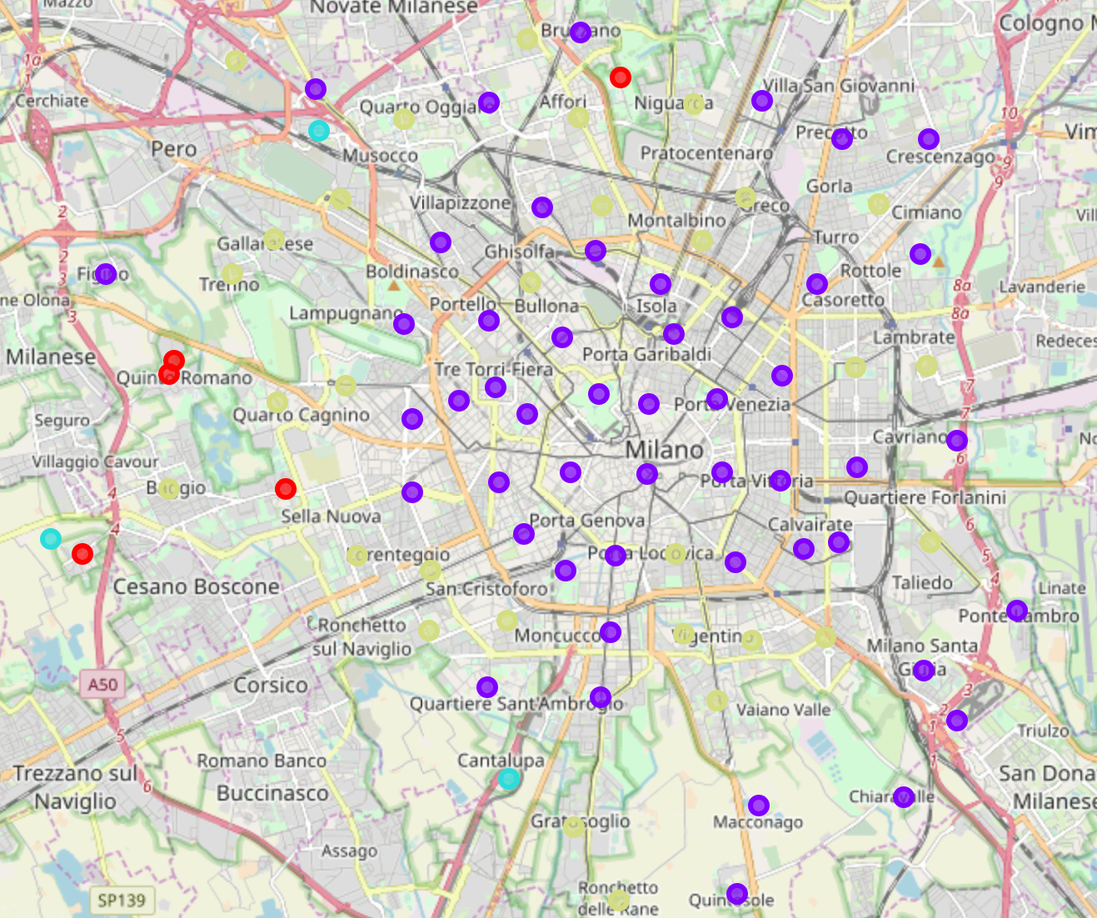

Figure 6 Map of Milan, with neighbourhoods’ clustering, by venue composition, indicated by colour.

## Clustering of Milan’s neighbourhoods, based on price tier and rating of food venues

I used the scikit learn KMeans clustering algorithm, and tried different number of clusters to find the optimum results, i.e. clustering in groups sufficiently different, without excessive polarisation or many single-element clusters. As in the analysis, the optimal number of clusters is four, as it provides insight without excessively oversimplifying or fragmenting the data ensemble.

The outcomes table is reported in Figure 7. Clustering is done in the parameters space generated by the price tier and ratings, as heat is a dependent variable and would not add any information. The coordinates reported represent the average cluster coordinates, and can be disregarded, since the clusters are roughly distributed in a polar way around the city centre. The geographical distribution of the clusters is shown Figure 8.

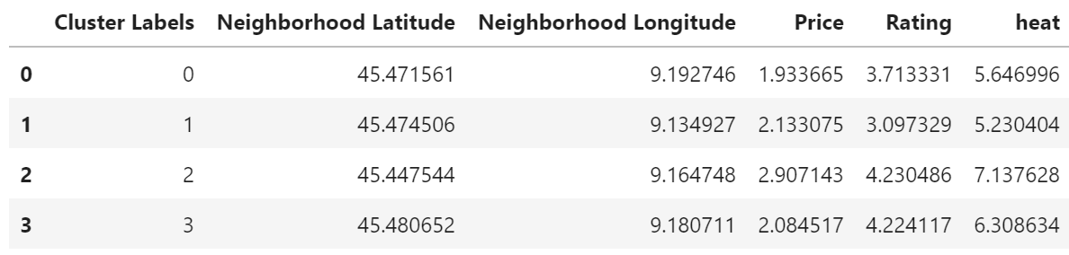

Figure 7 Table summarising the average price, rating and heat indicator values for Milan clusters, clustered based on price and rating.

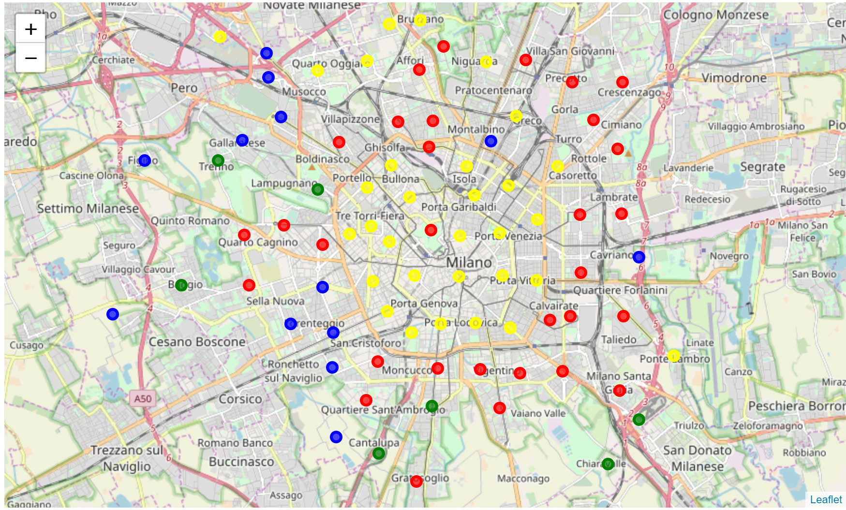

Figure 8 Map of Milan, with neighbourhoods’ clustering, by price and rating, indicated by colour.

The clustering provides clear insight on the presence of different kinds of neighbourhoods in Milan, and is definitely a proof that a city centre is not just a geographical concept. The clusters may be described as:

* **Cluster 0** (Red): the neighbourhoods in this cluster are mostly working class areas, and are mostly located just outside the inner ring road;
* **Cluster 1** (Blue): ): the neighbourhoods in this cluster are mostly in peripheral areas, sometimes working class areas, or close to the motorway ring road or other infrastructures, such as train stations;
* **Cluster 2** (Green): the neighbourhoods in this cluster are a bit on the outskirts, close to ring road or more "countryside" areas. The high price and rating might be influenced by the presence of attractions, shopping malls, event venues;
* **Cluster 3** (Yellow): the neighbourhoods in this cluster are centrally located, mostly middle class neighbourhoods, with some exceptions near the international exposition centre, or other services such as hospitals, university and newly redeveloped areas, up and coming areas.

It is possible to interpret the clustering shown in light of the average values of price tier and rating, but also with the heat indicator, as it varies markedly between clusters. We can take single neighbourhood heat values (averaged over the local venues) and plot it as a map, to create Milan’s heat map, as shown in Figure 9. The neighbourhoods are represented with black crosses. To create this map, I used interpolation to get values between data points.

The model clearly over-fits at the corners and on the edges, which we should disregarded. For example, the southeast corner appears to have a very high heat value, but that is based on the artefact that the nearby points belong to cluster 2 and 3, and thus affect the local heat gradient so that the extrapolation in that area is skewed.

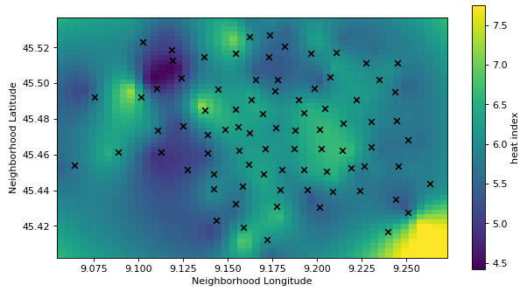

Figure 9 Heat map on Milan’s spatial coordinates map. Black crosses mark the relative position of neighbourhoods, and heat values between them are filled by interpolation. Extrapolated values at corners and or on edges not to be considered.

The map clearly looks like having a central region of high heat surrounded by an area of lower heat, with some exceptions, and reproduce the view seen with clustering accurately.

The significance of the heat indicator is reiterated by showing how it maps well with the clusters, meaning that the price tier and rating parameters are more or less correlated. Figure 10 plot the heat of all neighbourhoods in ascending order, with the bars coloured to indicate the cluster or reference. It is fairly easy to distinguish the clusters grouping together and not mixing randomly, meaning that heat can be used as a fairly accurate predictor of the cluster value and of the other information that comes along.

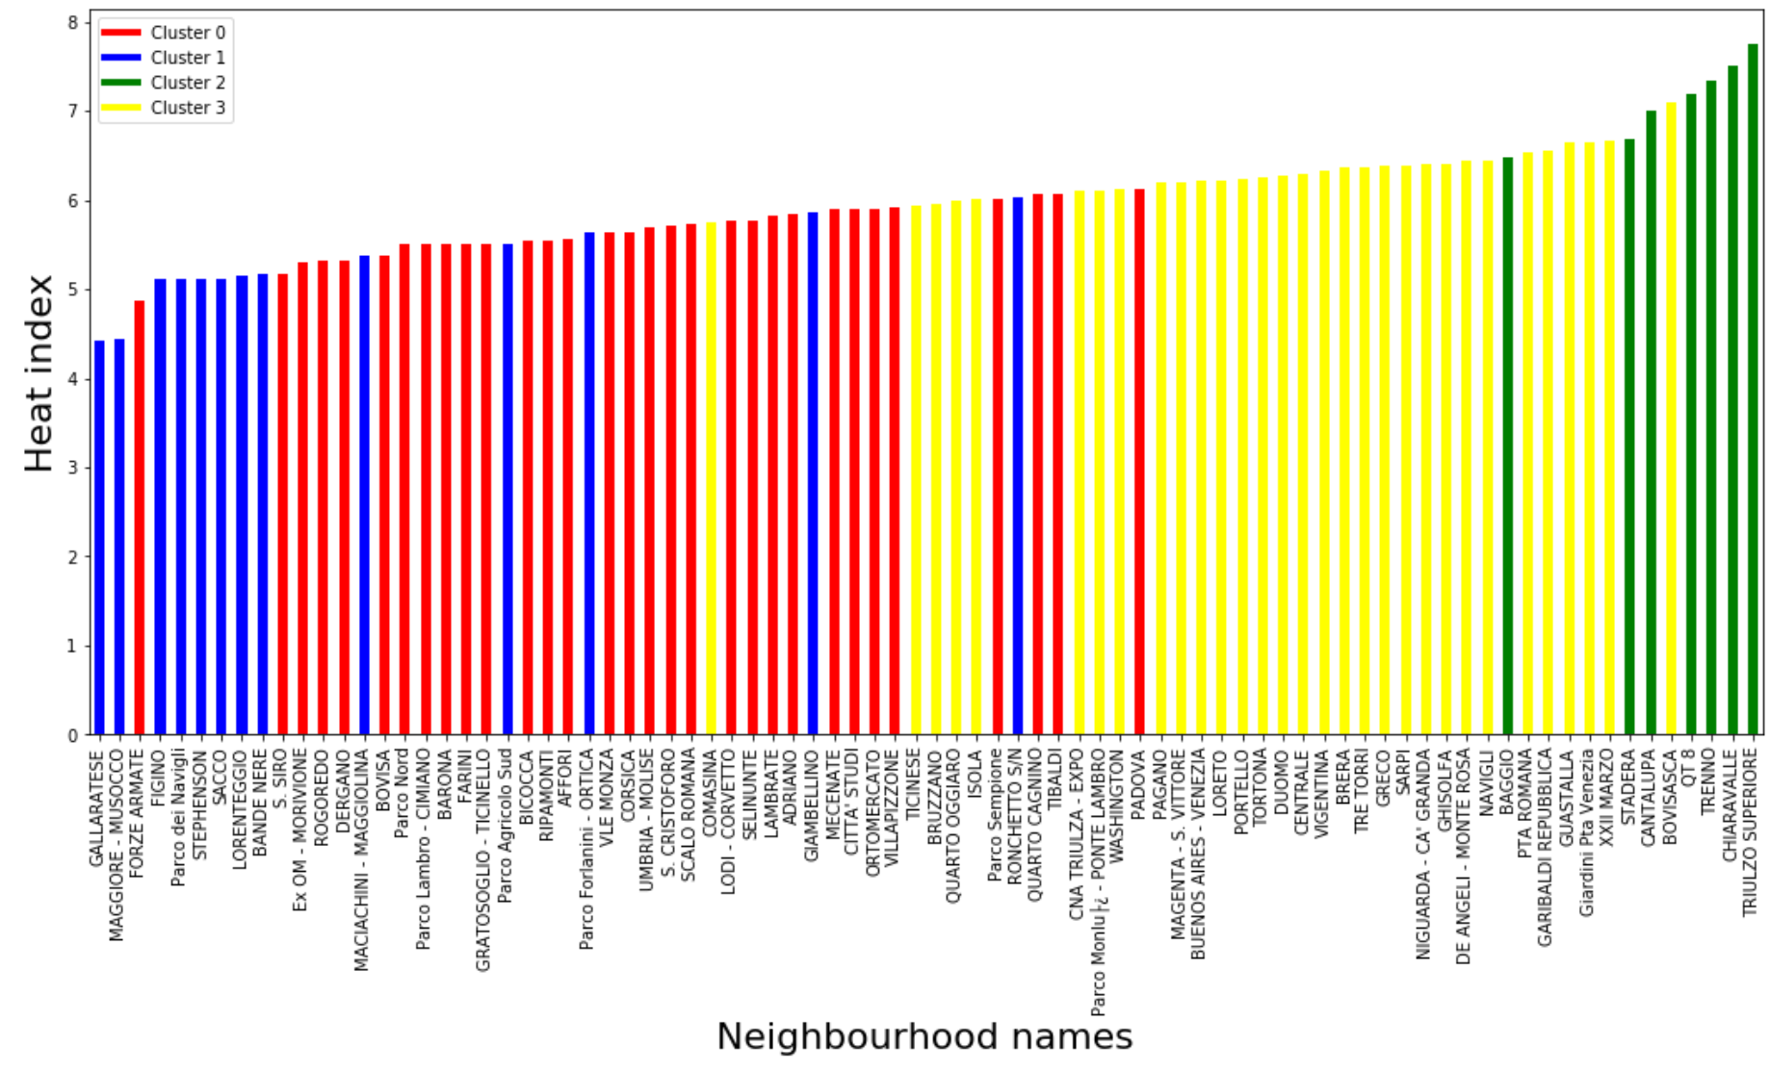

Figure 10 Heat value per neighbourhood, in ascending order. Bar colours match clustering, and show correlation between clustering and heat parameter.

In the next section, I am going to provide scenarios in which the data representation I have created can prove useful.

# Outcomes of the data analysis: scenario applications

## Scenario 1 – Where to open a given kind of restaurant

### Introduction

The choice of a location for a new restaurant depends on several factors, and a complete discussion of them is beyond the scope of this document. In this scenario, I will work under the hypothesis that the choice is based on three main factors:

* Concentration of competition, i.e. it is probably best to avoid areas with a very high concentration of similar businesses. At the same time, having a few similar venues nearby is not necessary bad, as it means that the target customers are often in the area;
* Kind of neighbourhood, i.e. some restaurants might be suited for business or central locations, others for residential areas, or areas with transportation links;
* Target price tier and rating of the area, i.e. the restaurant should aim to be competitive in terms of price and at least aligned to the local average rating.

To summarise, the investor should make sure to invest in area that is not saturated already, where their target customers are more likely to dwell and that their restaurant is not overpriced or too far from the local rating standard.

### Solving the problem

Let us say that we have an investor looking for a location for a Korean restaurant, and not one of those high street, mid-range Asian fusion restaurants, but a more authentic and high-end one. They are thus expecting to wind up in a high price tier (4-5) and get high ratings (4-5).

We can now set up a call of Yelp API to search for all Korean restaurants in town, and display them on a map. Note that the Yelp API has a limit of 50 venues returned per call, which means that if the number of venues exceeds 50 the task has to split geographically into separate calls. Figure 11 shows the distribution of existing Korean restaurants in Milan.

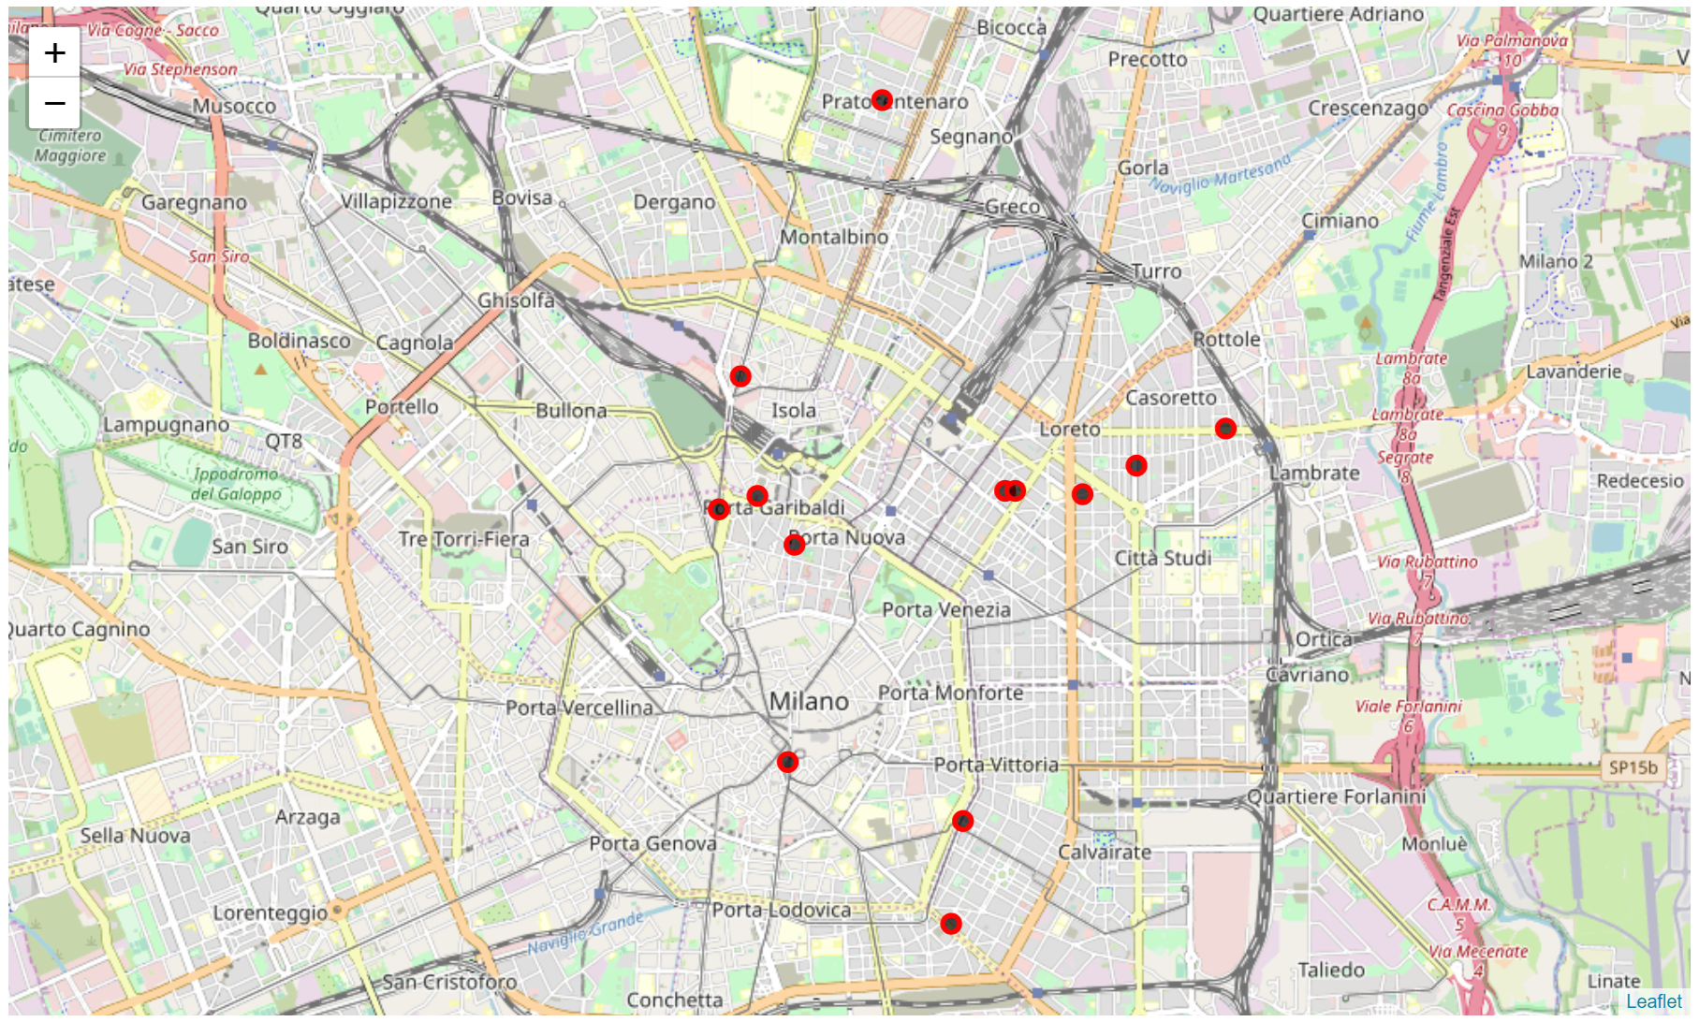

Figure 11 Map of Milan, with the location of Korean restaurants (as returned by Yelp API) marked by red and black dots.

It looks like there are not many Korea restaurants in Milan. Most of them are in the area between Loreto and Cittá Studi, heavily populated with students, and near Garibaldi station, an up-and-coming area recently subject to profound changes and re-development. We can list the main properties of the two areas:

|  |  |  |  |  |  |
| --- | --- | --- | --- | --- | --- |
| **Neighbourhood** | **Price tier** | **Rating** | **Heat** | **Price/rating cluster** | **Venue composition cluster** |
| Garibaldi | 2.29 | 4.27 | 6.55 | 3 | 1 |
| Loreto | 2.06 | 4.17 | 6.22 | 3 | 1 |

The table shows that the two neighbourhoods are similar. Given the hypotheses previously stated, one may recommend to invest in a neighbourhood with similar properties but lower concentration of Korean restaurants, and perhaps towards the high end of the range of the heat parameter’s values.

From a quick search among the neighbourhoods database, done simply by filtering parameters’ value, I can recommend:

|  |  |  |  |  |  |
| --- | --- | --- | --- | --- | --- |
| **Neighbourhood** | **Price tier** | **Rating** | **Heat** | **Price/rating cluster** | **Venue composition cluster** |
| XXII Marzo | 2.25 | 4.42 | 6.67 | 3 | 1 |
| Pta Venezia | 2.30 | 4.35 | 6.65 | 3 | 1 |
| Vigentina | 2.17 | 4.15 | 6.32 | 3 | 3 |

The neighbourhoods suggested are quite similar to Garibaldi and Loreto neighbourhoods, in that they are just within or close to the inner ring road (in orange on the map), are well integrated into the transport network (underground, railways) and are middle class – high end locations, as testified by the clustering analysis.

## Scenario 2 – Identifying new areas for a luxury shop

### Introduction

In this scenario, I am looking for a new location where it could be profitable to open a luxury shop or business, such as an up and coming area attracting new businesses and investments. The idea is that I want to stay away from the areas traditionally hosting most of the luxury venues (such as fashion, accessories, jewellery) to find areas with similar properties (as classified) but lower luxury business concentration.

### Solving the problem

To solve this problem, I can use the Yelp API to find all *luxury retail* venues in Milan. The venues returned by the API with such call are shown on the map in Figure 12.

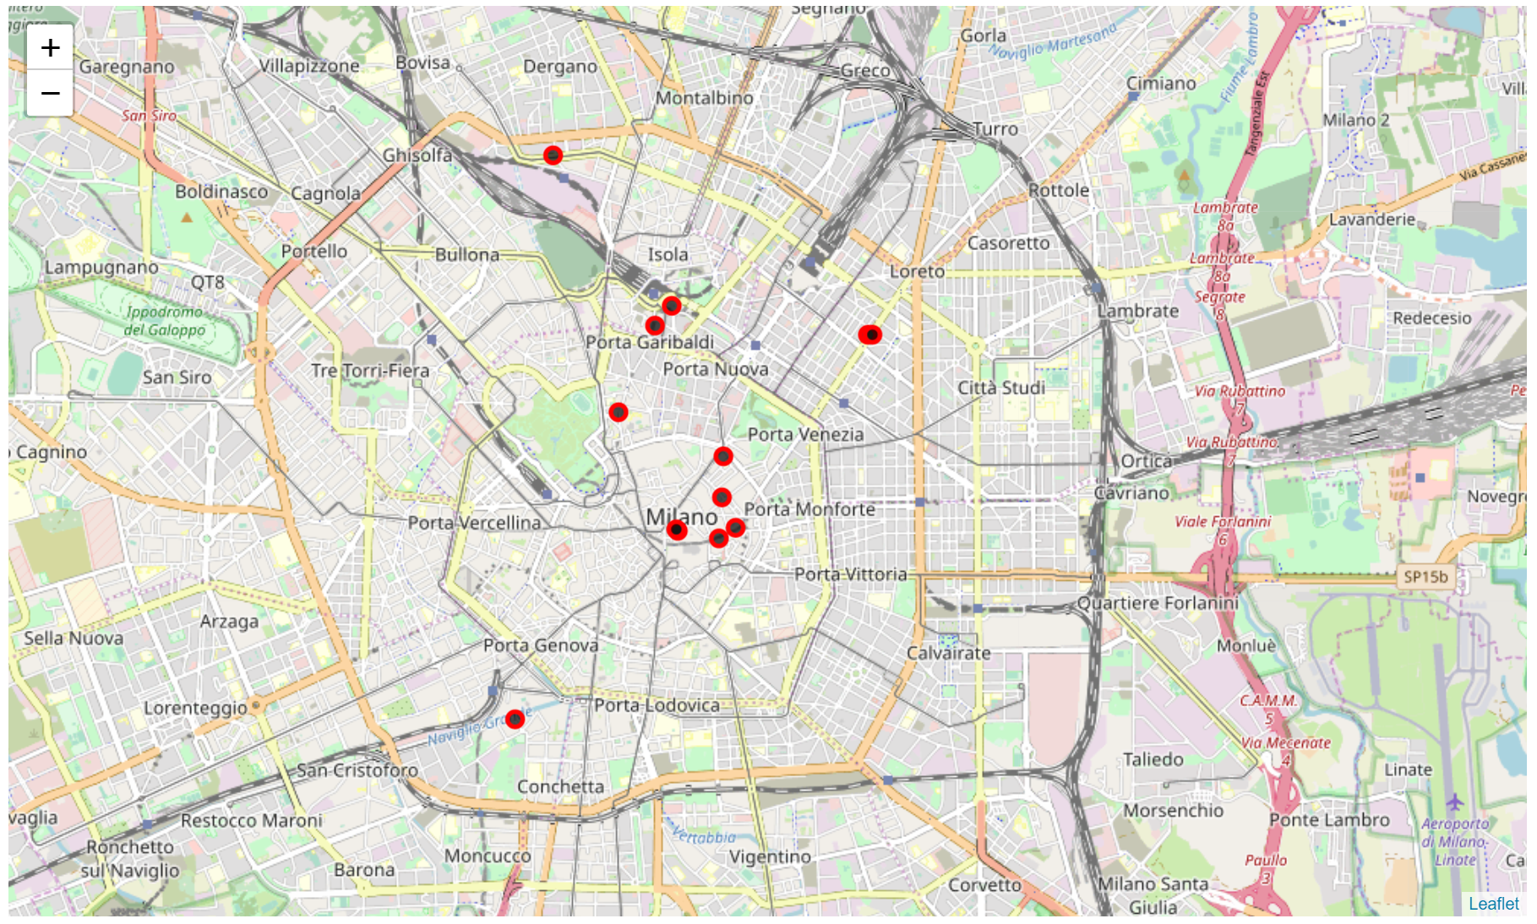

Figure 12 Map of Milan, with the location of venues tagged as luxury retail outlets (as returned by Yelp API) marked by red and black dots.

We can see that there is a concentration near neighbourhoods Duomo, Guastalla, Garibaldi. Too few venues are returned, and the information might thus be insufficient, meaning that broadening my research is necessary.

Searching for *luxury* alone through the Yelp API returns many more venues, as the map in Figure 13 shows. The search might now be too broad as venues such as ice cream shops are listed as luxury. It is thus necessary to define the search in more precise terms, and my choice is to search venues with a price filter, selecting venues in the highest price tier. The resulting list is a mix of retail and food venues, but they are somewhat geographically mixed, and present a clear picture. The map with the returned venues in Figure 14.

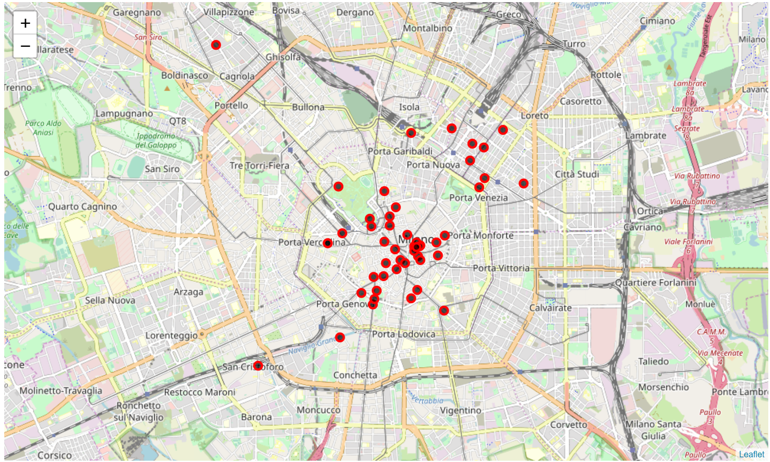

Figure 13 Map of Milan, with the location of venues tagged as luxury (as returned by Yelp API) marked by red and black dots.

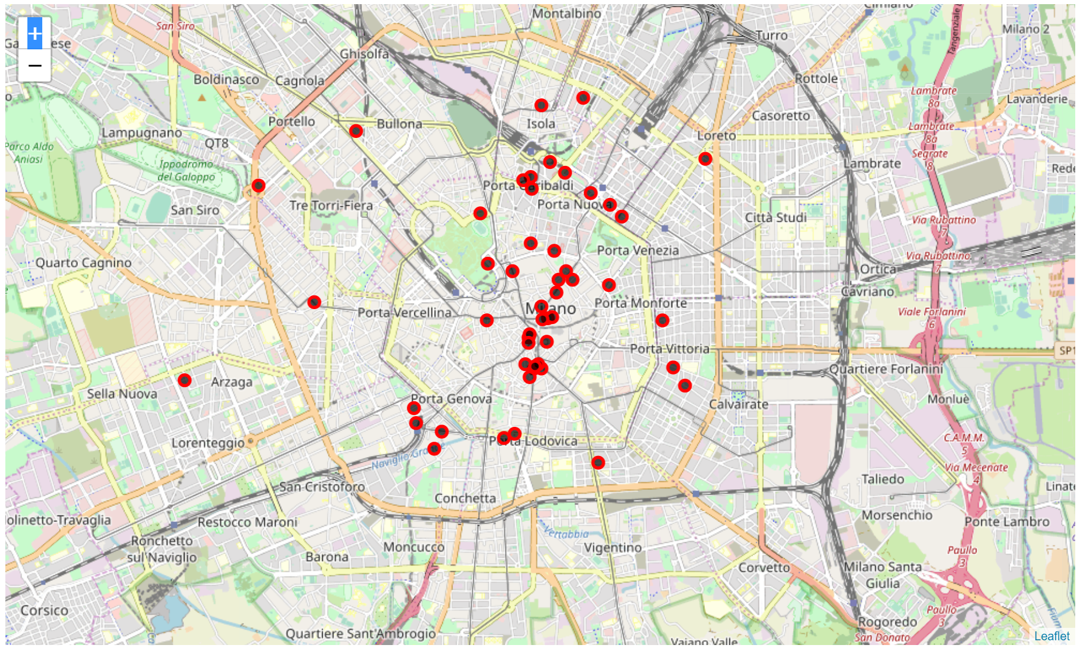

Figure 14 Map of Milan, with the location of venues tagged as most expensive (as returned by Yelp API) marked by red and black dots.

Once completed our search, we can list the neighbourhoods characterised by the highest concentration of luxury venues:

|  |  |  |  |  |  |
| --- | --- | --- | --- | --- | --- |
| **Neighbourhood** | **Price tier** | **Rating** | **Heat** | **Price/rating cluster** | **Venue composition cluster** |
| Duomo | 2.04 | 4.23 | 6.27 | 3 | 1 |
| Garibaldi-Repubblica | 2.29 | 4.27 | 6.55 | 3 | 1 |
| Brera | 2.08 | 4.28 | 6.37 | 3 | 1 |

These neighbourhoods are all very central and very similar in terms of venue composition, average prices and rating. If you know Milan, you would not be surprised, as many of the famous design, fashion and style boutiques are in those areas, which also host many much of the high-end restaurants and entertainment venues of the whole city. It is thus demonstrated that similarities between these neighbourhoods are multi-layered. We can now use these similarities to recommend a neighbourhood, which might be the up and coming place for luxury, according to the following criteria:

* Similarity in clustering, price, rating a heat indicators;
* Geographical proximity to current luxury areas, to avoid isolated or inconveniently located neighbourhoods;
* Low but not null presence of luxury venues, to remove risks involved with pioneering, or to avoid areas with concentrations of other kinds of business.

The most efficient approach is to see which neighbourhoods have a low concentration of luxury venues, and are located reasonably close to the centre. We can exclude some of them based on the kind of neighbourhood they are, using information easily collectable. The SARPI neighbourhood is known as Chinatown, and while it is relatively central and very well looked after and kept, it might not be suited for the purpose. PTA VENEZIA area is home many entertainment and food venues, and the kind of retail venues in the area are more mid-to-low end.

|  |  |  |  |  |  |
| --- | --- | --- | --- | --- | --- |
| **Neighbourhood** | **Price tier** | **Rating** | **Heat** | **Price/rating cluster** | **Venue composition cluster** |
| Tortona | 2.14 | 4.12 | 6.26 | 3 | 1 |
| Navigli | 2.17 | 4.27 | 6.44 | 3 | 1 |
| Guastalla | 2.23 | 4.42 | 6.64 | 3 | 1 |
| Ticinese | 1.71 | 4.22 | 5.93 | 3 | 1 |
| Isola | 1.79 | 4.22 | 6.01 | 3 | 1 |

TORTONA, NAVIGLI and TICINESE are close to each other and can be grouped together. TORTONA is home to design studios, NAVIGLI is famous for entertainment venues, art studios and small craft shops, whereas TICINESE has a mix of restaurants, entertainment places and retail.

GUASTALLA is close to DUOMO and many luxury venues; ISOLA is close to GARIBALDI and has undergone major re-development.

This final list of neighbourhoods matches all three selection criteria, and thus represents our data-based recommendation.

# Extra

## Comparison between Milan and Toronto neighbourhoods based on venue composition

I decided to compare the clustering between Milan and Toronto understand if there are similarities in the venue composition of these two important cities. The idea is to mix the data frames containing the popular venues per neighbourhood of both cities, and then running a clustering algorithm to see if they are distinguishable. The two cities are obviously broadly different in many ways, and many factors such as estate value, salaries and kind of business might vary broadly. However, I thought that venue composition might be somewhat influenced by the kind of jobs and value of business around, and generally tied to the kinds of neighbourhood (residential, business, parks, etc.), which can be assumed to be common between country with similar levels of development.

The optimal number of cluster for the model is 3, as one contains two “outlier” neighbourhoods (curiously one per city), and the other two the rest of the neighbourhoods. A higher number of clusters leads to the formation of very small clusters of one element mostly. The outcome shows how cluster 1 contains all Toronto elements (minus the outlier, in cluster 2) and roughly half of Milan’s elements. The rest of Milan’s neighbourhoods are in cluster 0. What is interesting is that the distribution does not seem to be random: Milan’s “Toronto-like” areas (cluster 1, purple) are mostly located out of the centre, in a C shape, as shown in Figure 7.

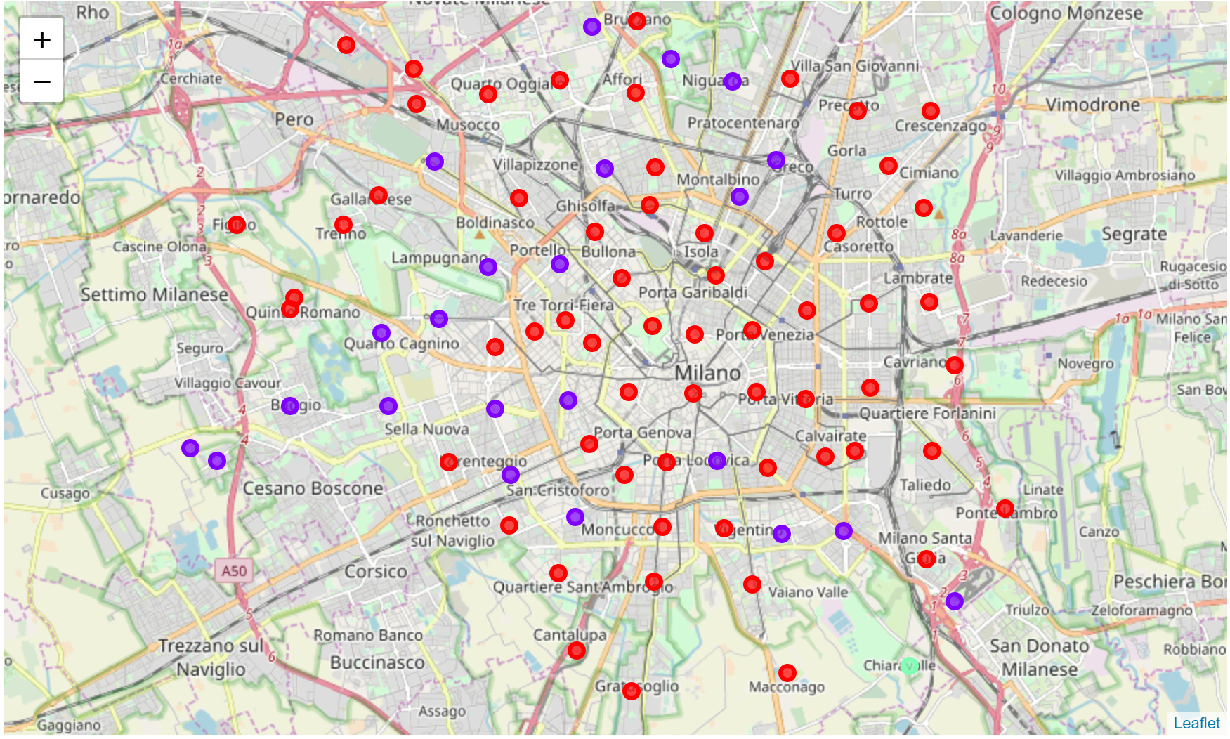

Figure 15 Map of Milan with its neighbourhoods clustered according to similarity with Toronto clusters. Cluster 0 in red, cluster 1 in purple, cluster 2 (outlier) in turquoise.

Many of the areas clustered in cluster 1 are residential and/or have undergone redevelopment, which might suggest alignment to a more modern city like Toronto. This might also mean that residential areas in different cities maintain levels of similarity, more than business or touristy areas.